1-Affix

🔤 What is an Affix?
# Source: Chatgpt (GPT-4-turbo) at [7/22/2025]
An affix is a morpheme (a small unit of meaning) that is added to a word root or base to create a new word or change its grammatical form (such as tense, number, or part of speech).

📘 Definition:
# Source: Chatgpt (GPT-4-turbo) at [7/22/2025]
An affix is a bound morpheme that is attached to a root, base, or stem to modify its meaning or function.

🧠 Key Characteristics:
# Source: Chatgpt (GPT-4-turbo) at [7/22/2025]
- Affixes are bound morphemes — they cannot stand alone.
- They are added before, within, or after a word.
- They help create new words or change grammar (like turning a verb into a noun).

🔍 Types of Affixes:
# Source: Chatgpt (GPT-4-turbo) at [7/22/2025]
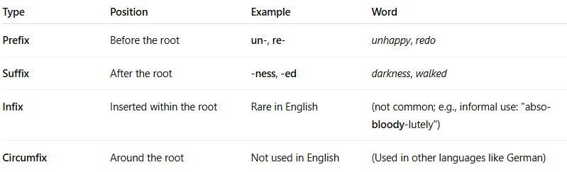

Type | Position | Example | Word
Prefix | Before the root | un-, re- | unhappy, redo
Suffix | After the root | -ness, -ed | darkness, walked
Infix | Inserted within the root | Rare in English | (not common; e.g., informal use: "abso-bloody-lutely")
Circumfix | Around the root | Not used in English | (Used in other languages like German)

🧾 Examples:
# Source: Chatgpt (GPT-4-turbo) at [7/22/2025]
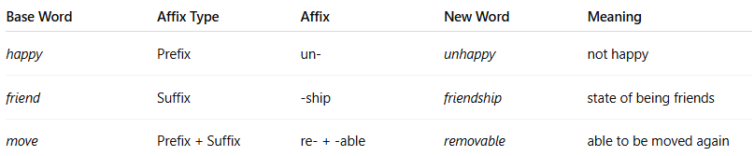

Base Word | Affix Type | Affix | New Word | Meaning
happy | Prefix | un- | unhappy | not happy
friend | Suffix | -ship | friendship | state of being friends
move | Prefix + Suffix | re- + -able | removable | able to be moved again

✅ Summary:
# Source: Chatgpt (GPT-4-turbo) at [7/22/2025]
An affix is a part added to a word root to change its meaning or function.
Types include:
- Prefix (before),
- Suffix (after),
- Infix (inside), and
- Circumfix (around — not used in English).

2-Inflection

📘 What is Inflection in Linguistics?
# Source: Chatgpt (GPT-4-turbo) at [7/23/2025]
Inflection is the process of adding affixes (usually suffixes) to a word to show grammatical information such as:
- Tense
- Number
- Gender
- Case
- Person
- Aspect
- Mood
- Voice

🧠 Key Idea:
# Source: Chatgpt (GPT-4-turbo) at [7/23/2025]
Inflection changes the form of a word without changing its core meaning or part of speech.
It is not used to create new words — that’s derivation.

🔍 Examples of Inflection in English:
# Source: Chatgpt (GPT-4-turbo) at [7/23/2025]
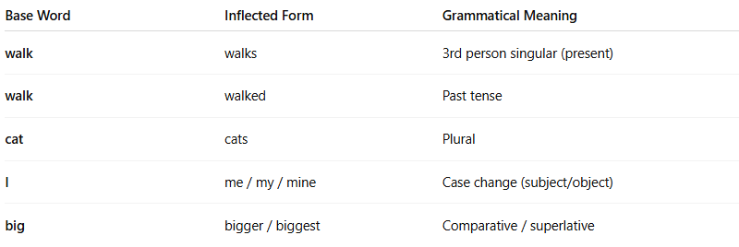
Base Word | Inflected Form | Grammatical Meaning
walk | walks | 3rd person singular (present)
walk | walked | Past tense
cat | cats | Plural
I | me / my / mine | Case change (subject/object)
big | bigger / biggest | Comparative / superlative

⚖️ Inflection vs. Derivation:
# Source: Chatgpt (GPT-4-turbo) at [7/23/2025]
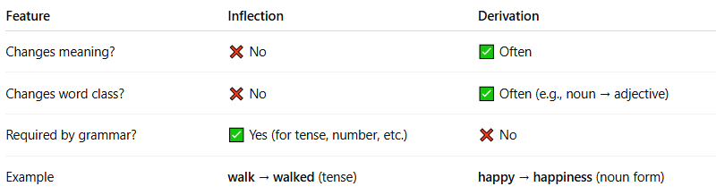
Feature | Inflection | Derivation
Changes meaning? | ❌ No | ✅ Often
Changes word class? | ❌ No | ✅ Often (e.g., noun → adjective)
Required by grammar? | ✅ Yes (for tense, number, etc.) | ❌ No
Example | walk → walked (tense) | happy → happiness (noun form)

🧾 More Inflection Examples:
# Source: Chatgpt (GPT-4-turbo) at [7/23/2025]
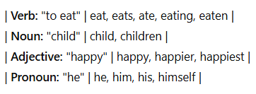
| Verb: "to eat" | eat, eats, ate, eating, eaten |
| Noun: "child" | child, children |
| Adjective: "happy" | happy, happier, happiest |
| Pronoun: "he" | he, him, his, himself |

✅ Summary:
# Source: Chatgpt (GPT-4-turbo) at [7/23/2025]
Inflection is the grammatical modification of a word to show tense, number, case, etc., without changing its basic meaning or part of speech.

3-Derivation

🔧 What is Derivation in Linguistics?
# Source: Chatgpt (GPT-4-turbo) at [7/23/2025]
Derivation is the process of creating a new word by adding an affix (usually a prefix or suffix) to a base or root word, which often changes its meaning and/or part of speech.

📘 Definition:
# Source: Chatgpt (GPT-4-turbo) at [7/23/2025]
Derivation is a type of word formation where affixes are added to a root to create a new word, often with a new grammatical category (e.g., noun → adjective, verb → noun).

🧠 Key Characteristics:
# Source: Chatgpt (GPT-4-turbo) at [7/23/2025]
- Creates new words
- Often changes the part of speech
- Uses derivational affixes
- May or may not preserve the root’s original meaning

🔍 Examples of Derivation:
# Source: Chatgpt (GPT-4-turbo) at [7/23/2025]
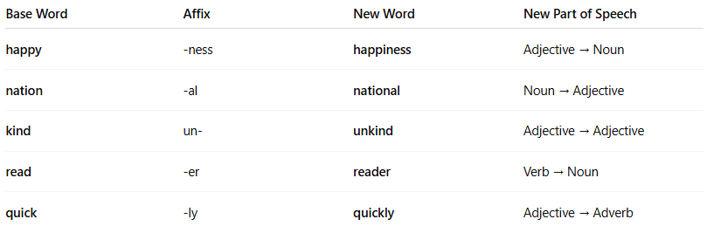

Base Word | Affix | New Word | New Part of Speech
happy | -ness | happiness | Adjective → Noun
nation | -al | national | Noun → Adjective
kind | un- | unkind | Adjective → Adjective
read | -er | reader | Verb → Noun
quick | -ly | quickly | Adjective → Adverb

⚖️ Derivation vs. Inflection:
# Source: Chatgpt (GPT-4-turbo) at [7/23/2025]
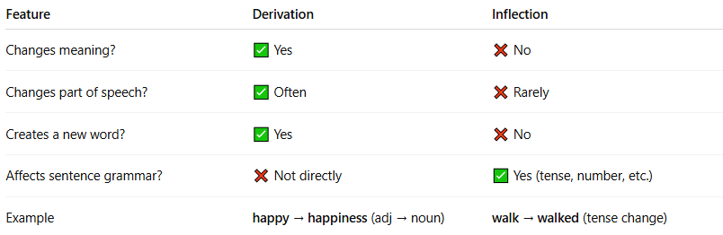

Feature | Derivation | Inflection
Changes meaning? | ✅ Yes | ❌ No
Changes part of speech? | ✅ Often | ❌ Rarely
Creates a new word? | ✅ Yes | ❌ No
Affects sentence grammar? | ❌ Not directly | ✅ Yes (tense, number, etc.)
Example | happy → happiness (adj → noun) | walk → walked (tense change)

🧾 More Derivational Affixes (English):
# Source: Chatgpt (GPT-4-turbo) at [7/23/2025]
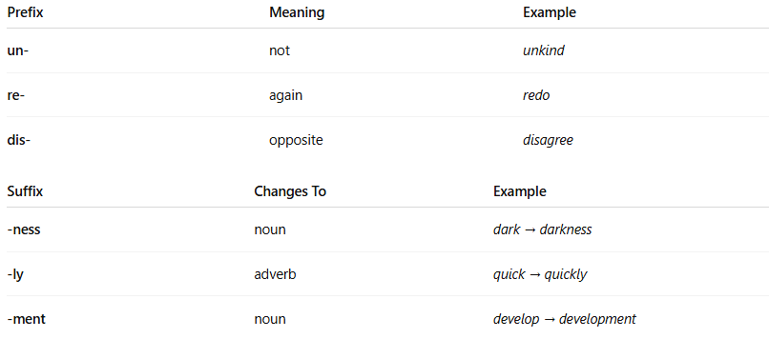

Prefix | Meaning | Example
un- | not | unkind
re- | again | redo
dis- | opposite | disagree

Suffix | Changes To | Example
-ness | noun | dark → darkness
-ly | adverb | quick → quickly
-ment | noun | develop → development

✅ Summary:
# Source: Chatgpt (GPT-4-turbo) at [7/23/2025]
Derivation is when a word is built from another word by adding an affix, often resulting in a new word with a new grammatical role or meaning.

